Grade 3-6 Homework

Term 3 - Week 5

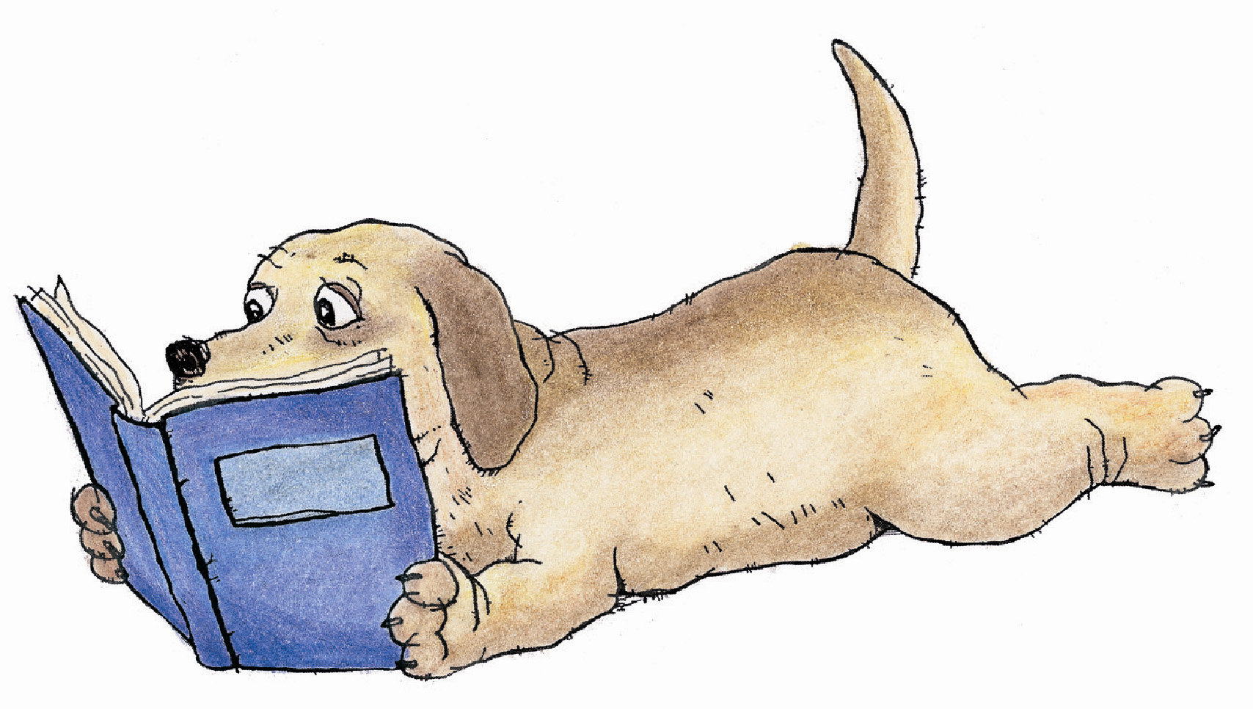 | Reading/Reader Blog  Read at least 10-15 minutes per night. Please remember to blog your reading by telling us the name of your book and to detail what you are reading about.  http://ipsreader.blogspot.com.au/  *Readers may still updated using the journal book if required.
Weekly Task

Prototyping to Design Piece

This week we take our prototypes, select one and create the final design piece for presentations on Friday.

Remember you are working on designing a final design of an Evernote licence. If your licence is voted to be the most suitable for our class, it will be used as the main design.

Do your best and use whatever resources you have available.

Name

Due Date | Friday 16th of August

